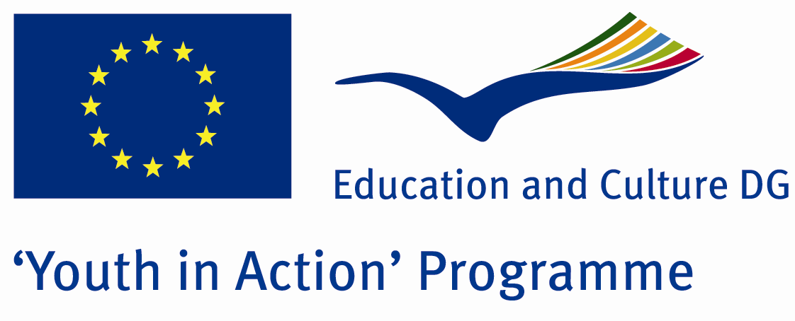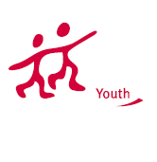

Action 1.1
Project Summary; Imagine the ancient men and compare it with the easy modern life. Is it possible to make it even easier? We believe; Yes we aim to invent creative projects to make it happen. What do you think?

Project Title; Imagine For Easy Life
Date and Venue ; 12-19 2013 February Turkey
Place: Hatay.

Target Group ; Municipalities, City Councils and Non-Governmental organizations,
youth groups,culture and art groups,e.t.c

Participants ; 5 people from each country (over 18 -25 ). Totally 7 countries.

Conditions ; Accommodation, board and programme costs will be financed through European Commission Youth in Action Programme . Travel costs will be reimbursed in 70% (APEX Tarrifs). Organizations from all 27 EU member countries plus Liechtenstein , Norway and Iceland are eligible to take part.

Working language: English

Organisator group: Group Payas

How to apply: If you are interested, please send your Part III forms to
by e-mail please (in word file). Scan Part3 format is enough for application.(Fulfilled Part III which you can find in the attachment, of course signed and stamped) ..

Contact e-mail: groupsymrnes@gmail.com
Group e-mail: grouppayass@gmail.com

Deadline to apply:20.09.2012

